**Remove search config**

<https://social.technet.microsoft.com/wiki/contents/articles/48051.sharepoint-2013-how-to-completely-remove-search-service-application.aspx>

App management>> search service applications >>manage search app (I guess) >> (ip/_admin/ serviceApplications.aspx search service application is link of page)

Open management shell and write follwoign command

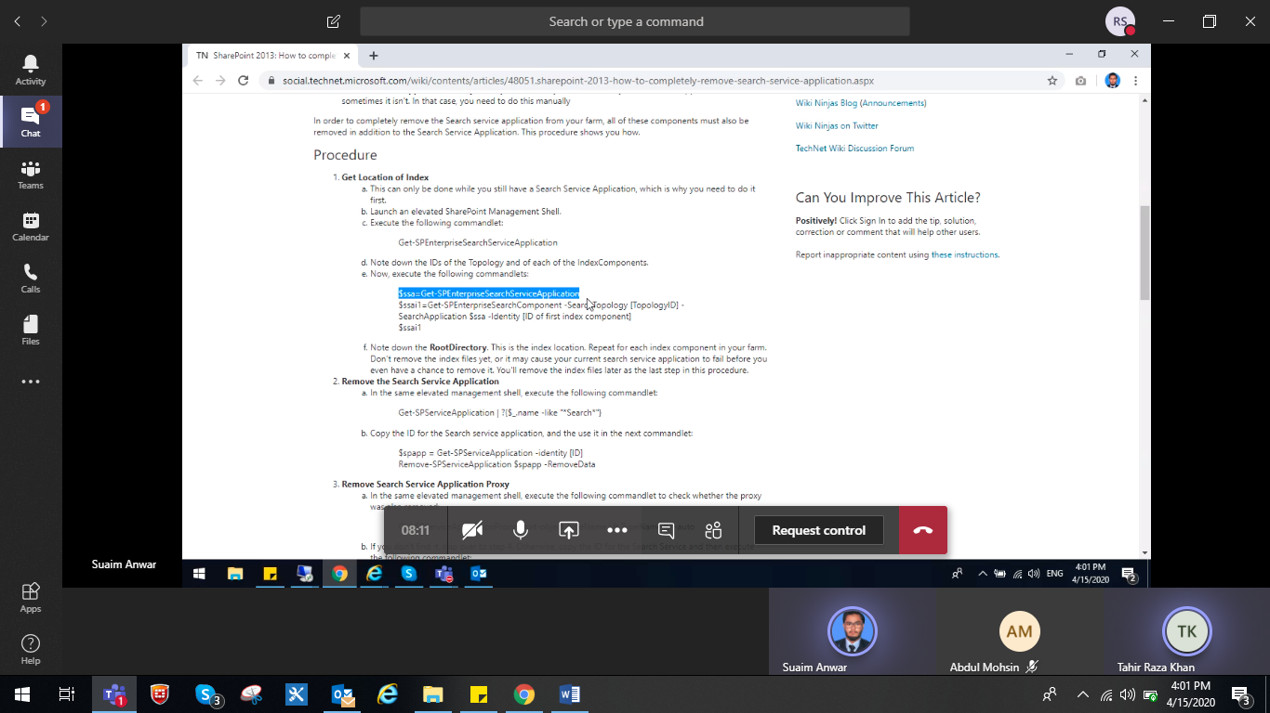

Toplology

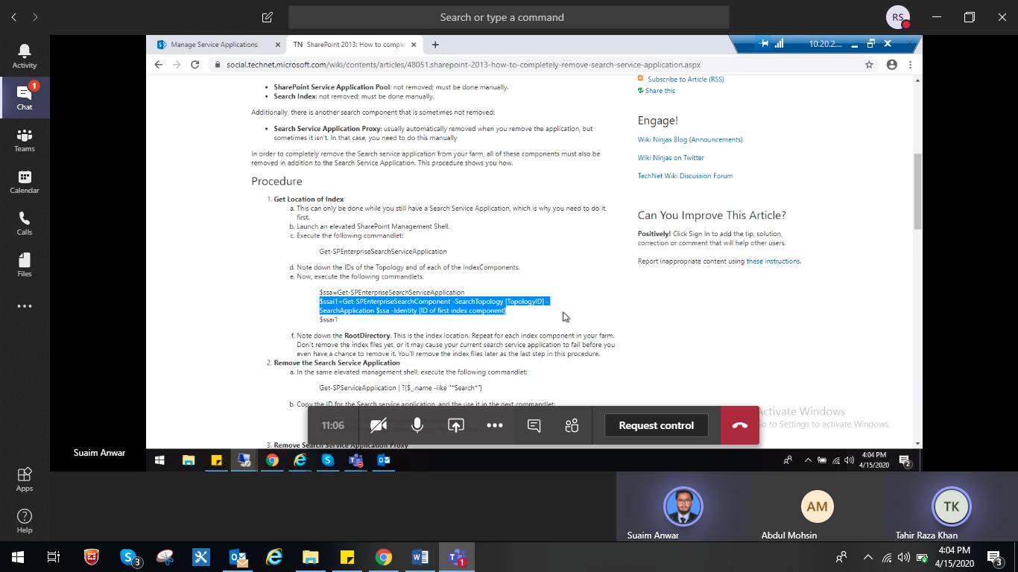

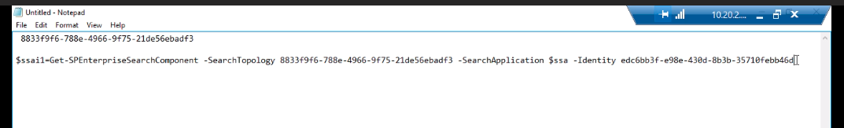

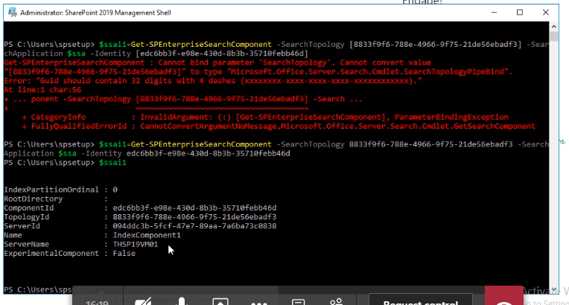



Write ID of service app as shown below

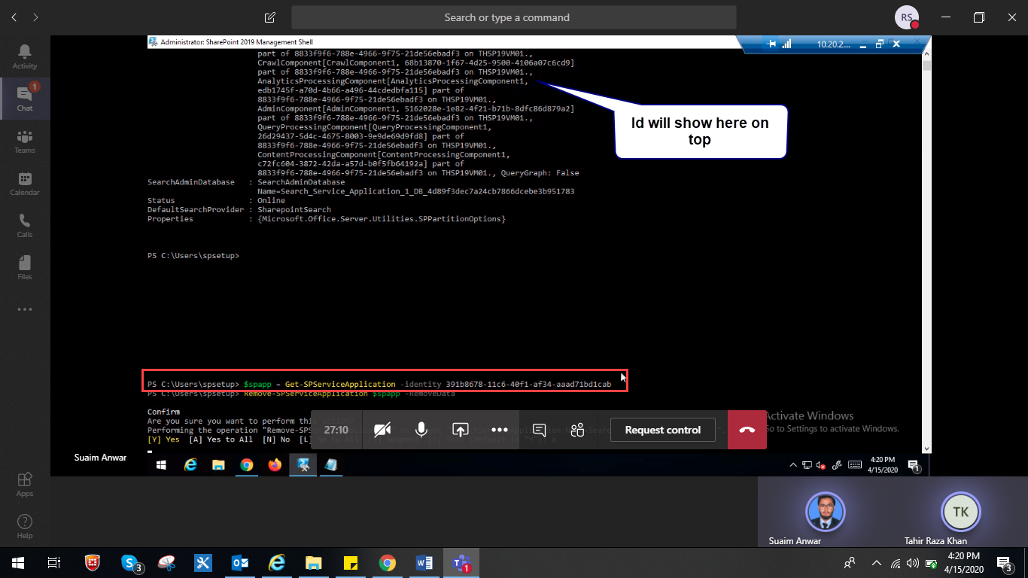

Remove app search proxy service